SARDAR VALLABHBHAI NATIONAL INSTITUTE OF TECHNOLOGY, SURAT
DEPARTMENT OF CIVIL ENGINEERING
STRUCTURAL ENGINEERING SECTION
ENGINEERING MECHANICS LABORATORY
Engineering Mechanics laboratory was established in the year 1961. The laboratory is located in front of Department of Civil Engineering, Wing-B. The laboratory facilities are utilized by undergraduate students of each specialization of engineering. This lab helps to understand the basics of mechanics. In this lab, students get a field experience of behaviour of different types of forces. The laboratory has good potential to carry out research and generate revenue using calibration and testing work in future. List of equipment available in the laboratory is given below:
Sr. No. | Equipment Name
1 | Universal force table apparatus
2 | Coplanar parallel forces apparatus
3 | Simple plane roof truss apparatus
4 | Fly wheel apparatus
5 | Static surface friction apparatus
6 | Belt friction apparatus
7 | Forces in space apparatus
LIST OF EXPERIMENTS
Engineering Mechanics Lab (B. Tech-I (All Branches), Semester I and II)
Sr. No. | Title of Experiment
1. | Plane force polygon
2. | Forces in space
3. | Simple plane roof truss
4. | Coplanar parallel forces
5. | ‘E’ by Searle’s apparatus
6. | Belt friction
7. | Static surface friction
8. | Gravitational acceleration
9. | Mass M.I. of inertia
10. | Determination of ‘g’ by Fletcher’s trolley

Photos of Some Experimental Set Ups

UNIVERSAL FORCE TABLE APPARATUS

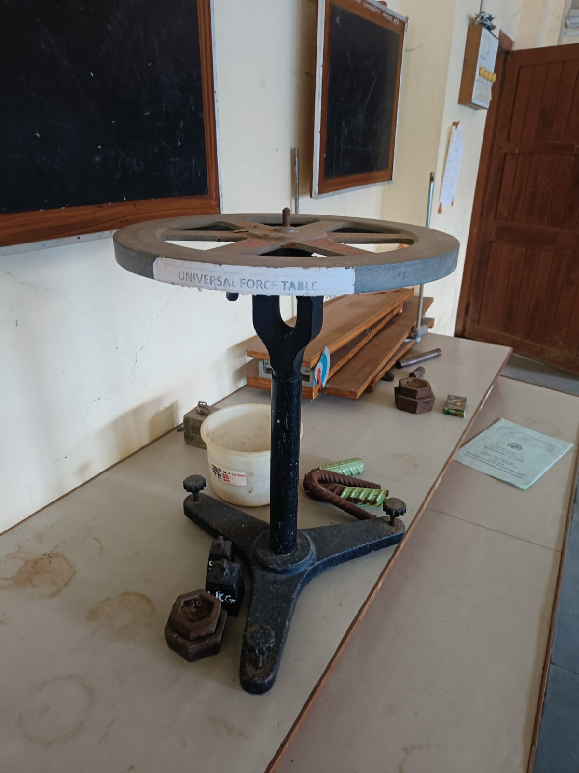

COPLANAR PARALLEL FORCES APPARATUS

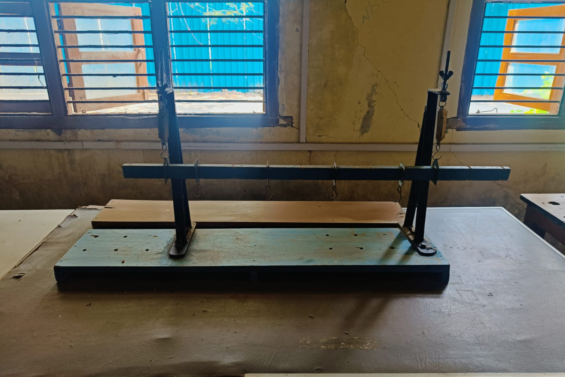

SIMPLE PLANE ROOF TRUSS APPARATUS

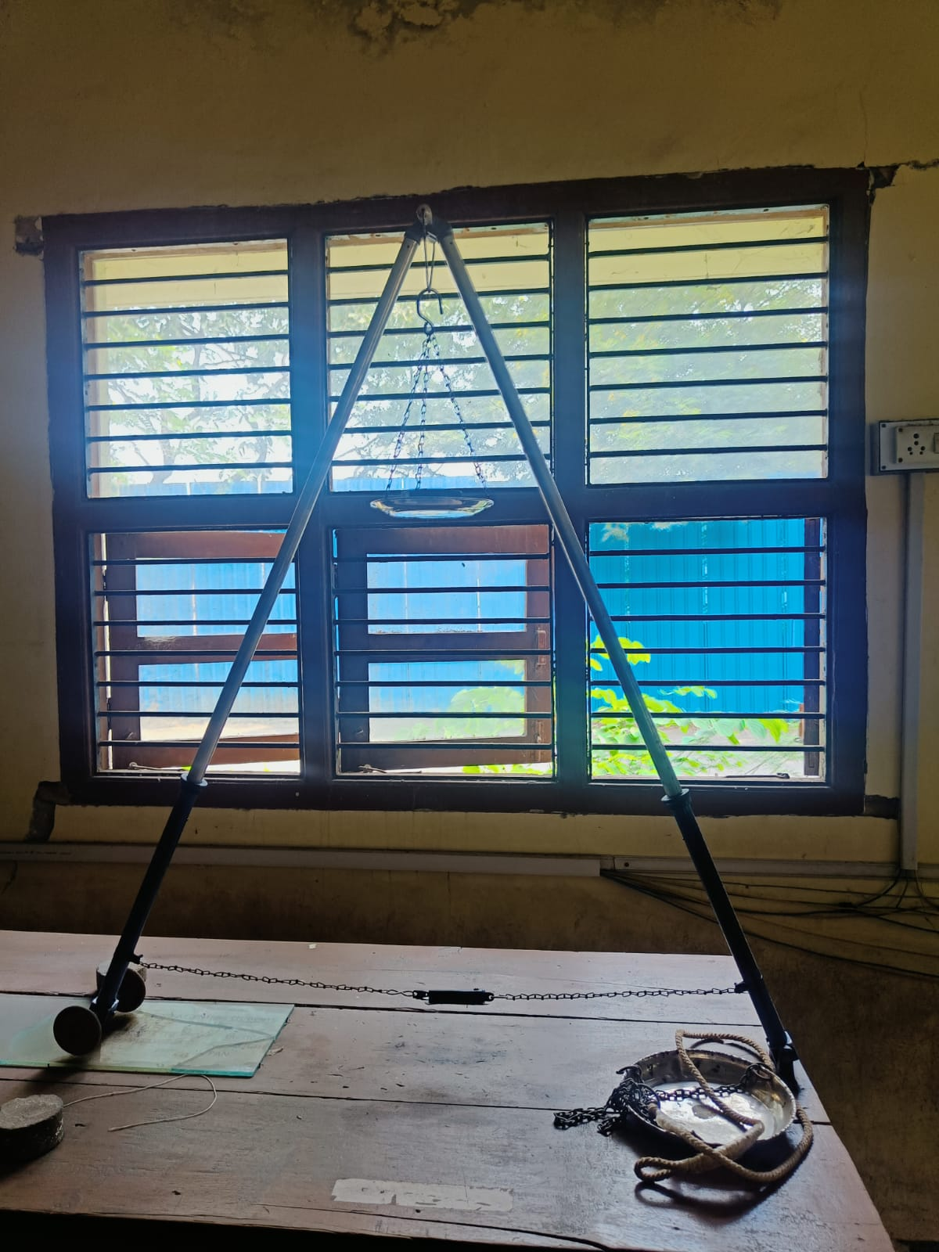

FLY WHEEL APPARATUS

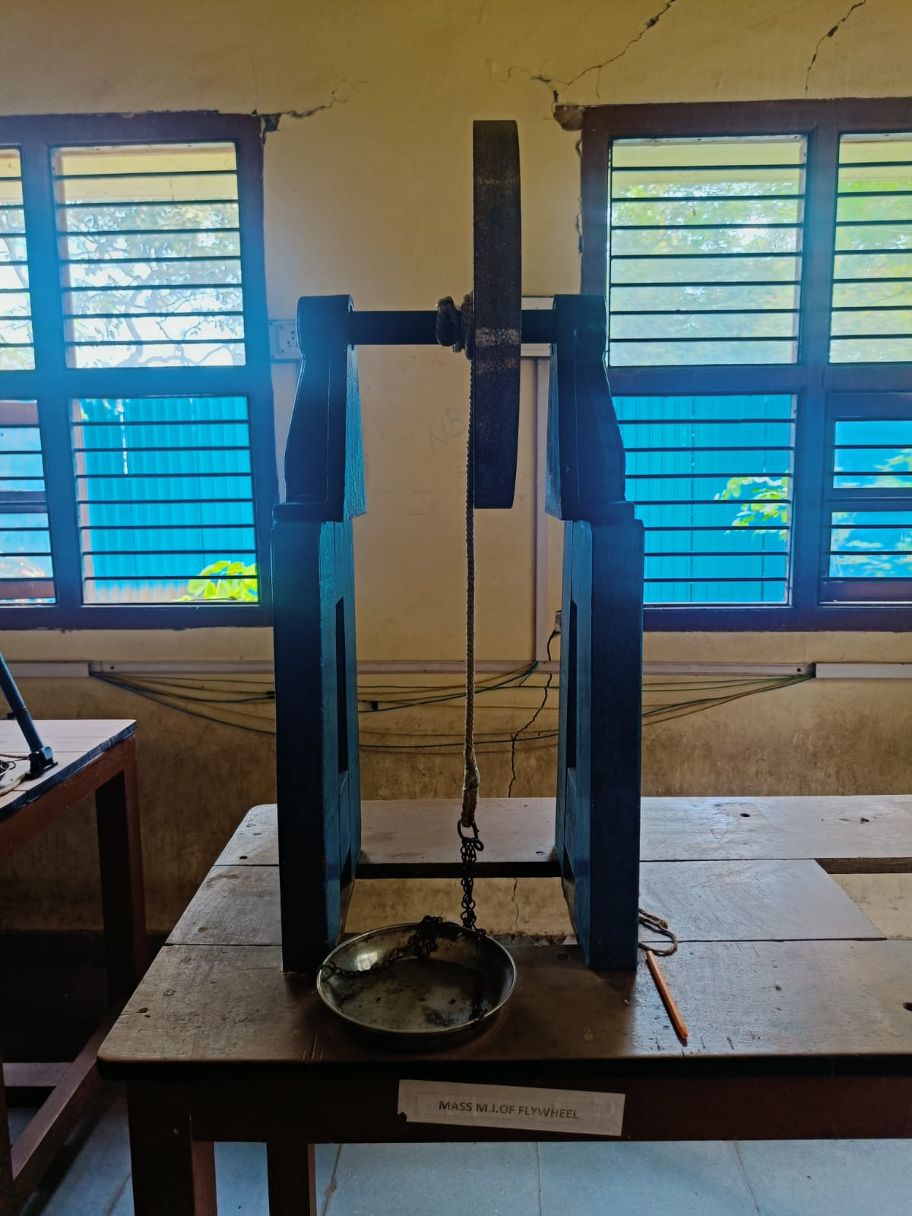

STATIC SURFACE FRICTION APPARATUS

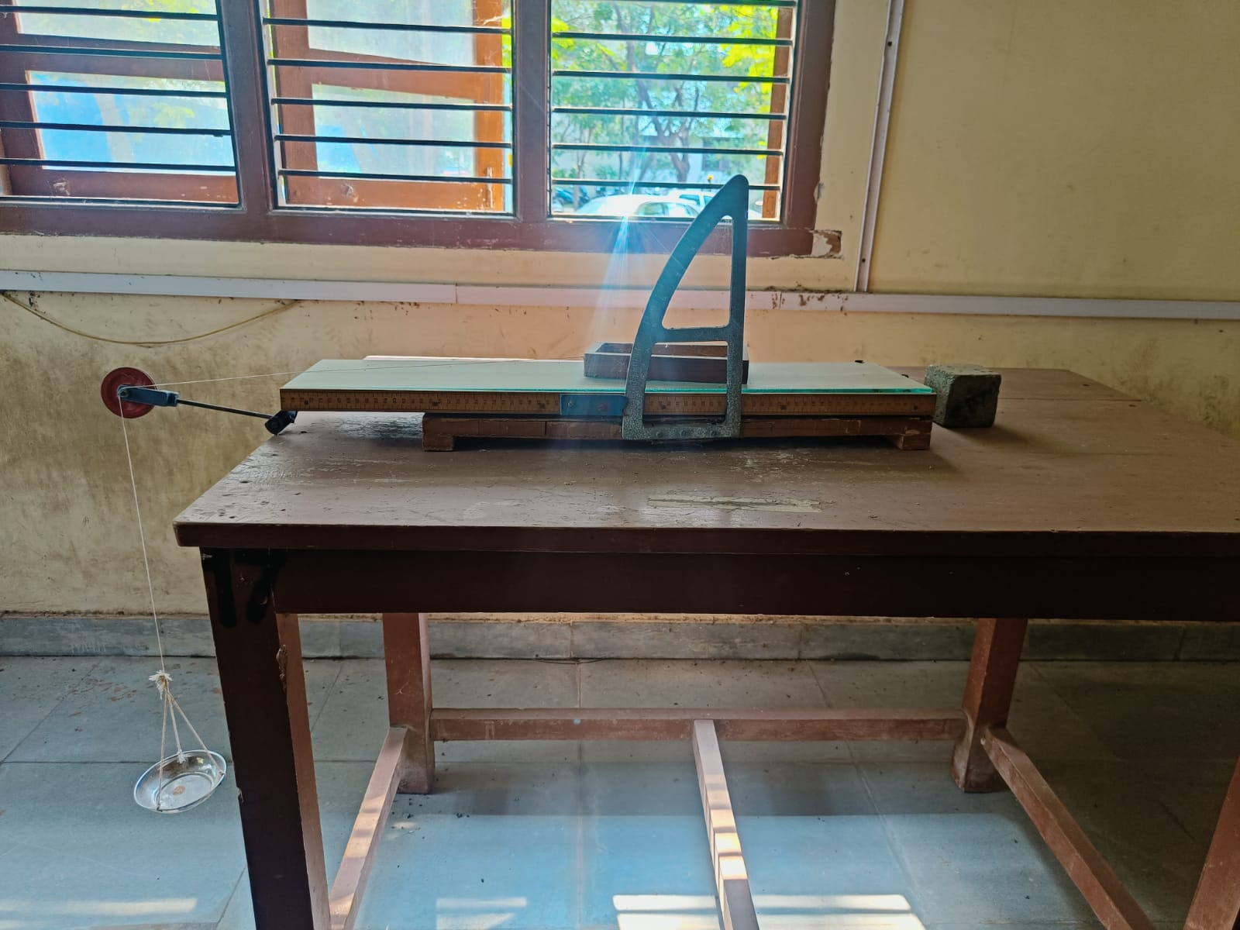

BELT FRICTION APPARATUS

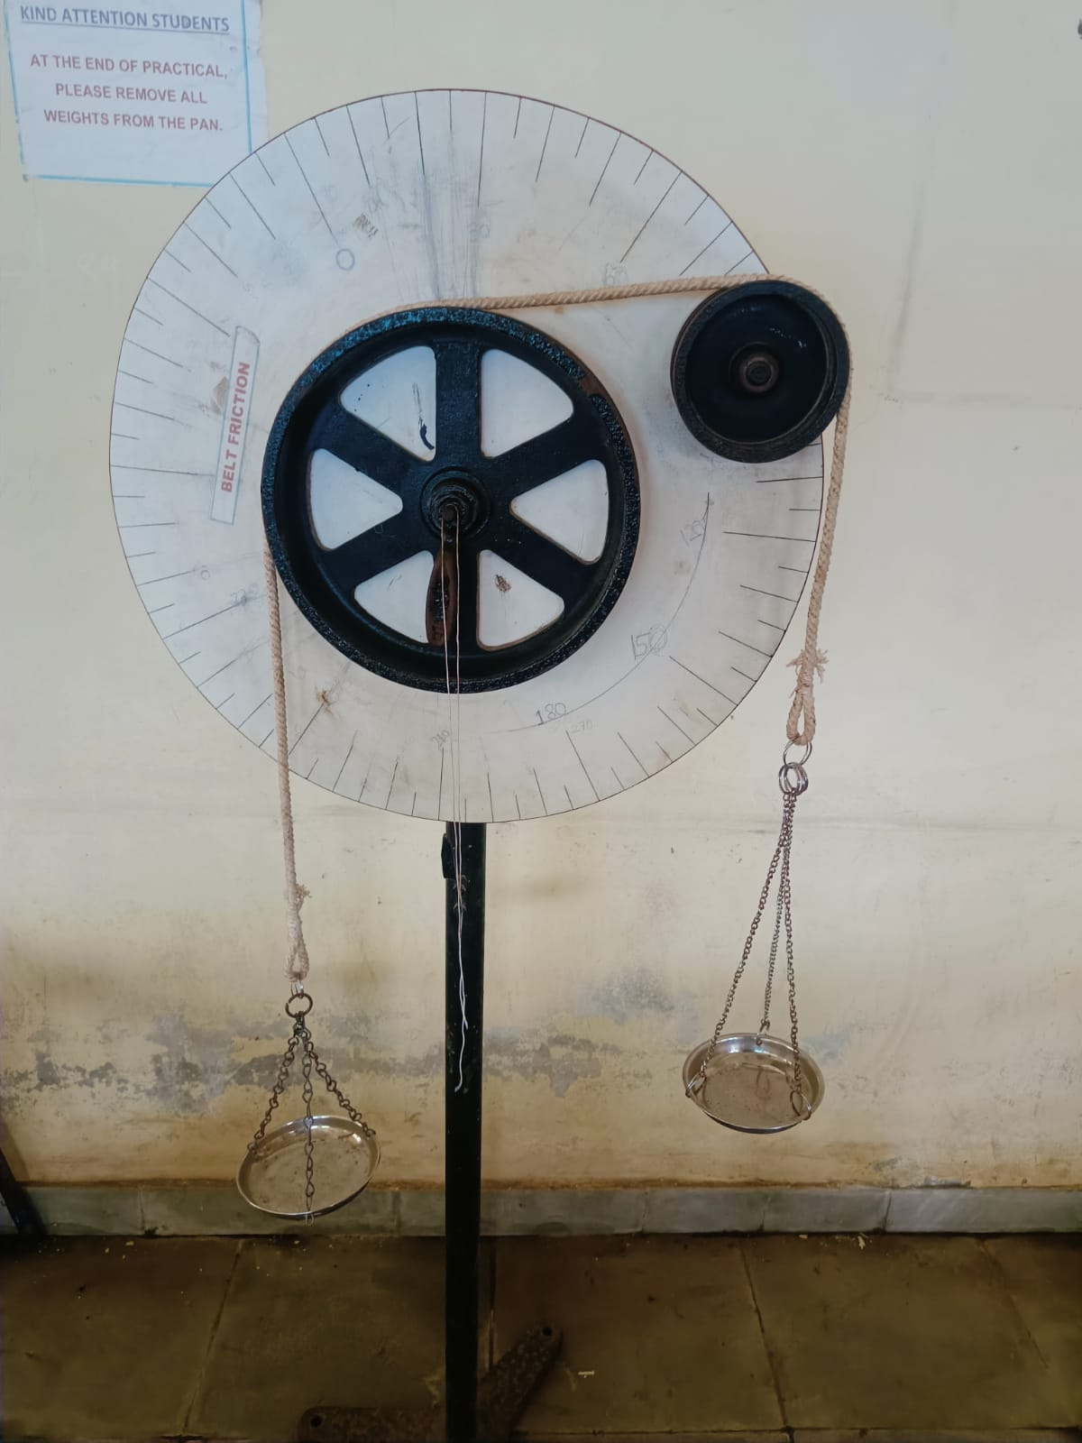

FORCES IN SPACE APPARATUS

